**Ex. No.: 7** Date: 31/03/2022

**Problem statement:**

Design a Restaurant data entry App using Mobile Application in Android Studio

Task to be Performed

1. Install Android Studio

2. Overview of creating Table Layouts

3. Study of creating different events using Activity Class

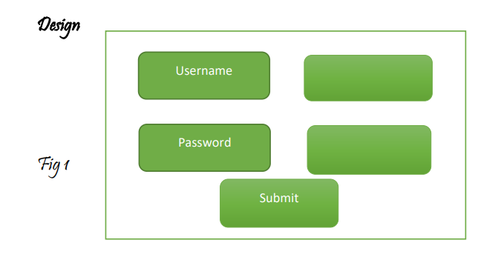

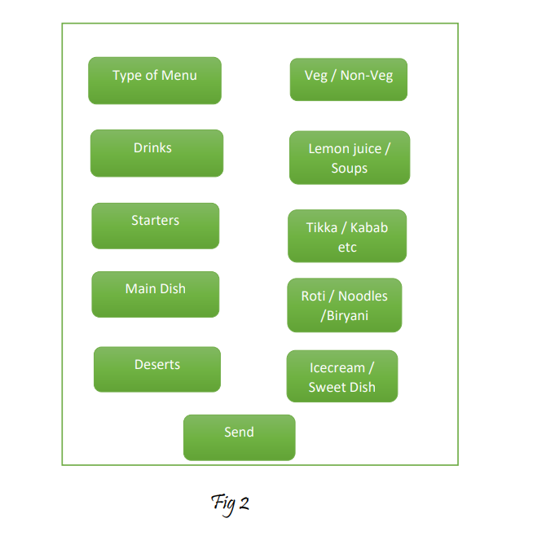

1. Using Table Layouts design the above in Android studio

2. Apply various events using Activity Class

3. In Fig 2 the second column should be a list of selection

4. More Creativity can be added accordingly

**Design: (Block diagram)**

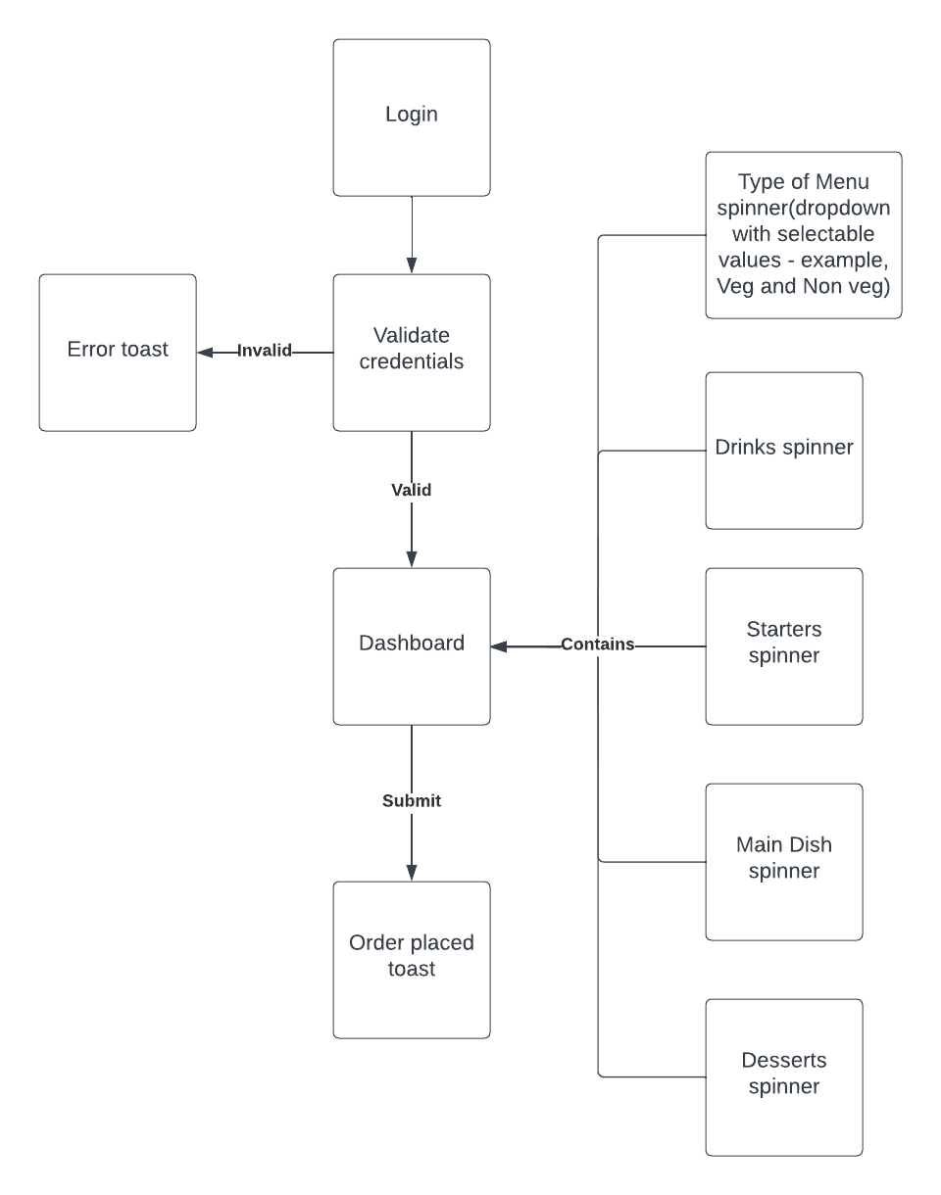

**Tool used:**

* Android Studio
* Java
* XML

**Code:** <https://drive.google.com/drive/folders/1RyIOz45dKejSlrJfZ0lD0xgrr3CKPyW6?usp=sharing>

**Screenshots of application:**

